From the Start menu, find the Python you have installed.

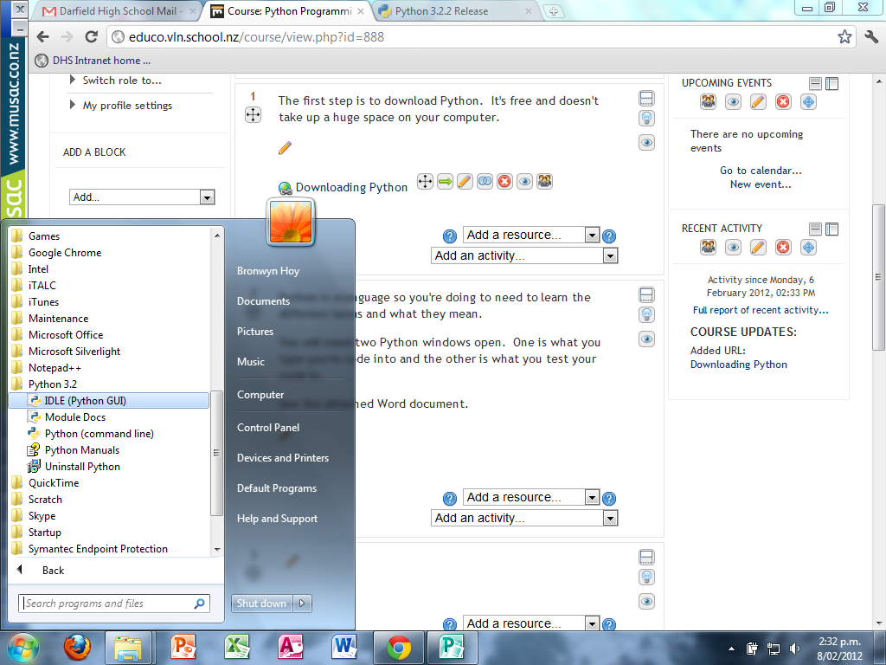

Click on IDLE Python GUI. Go to File and New Window.

Arrange your windows so they are beside each other.

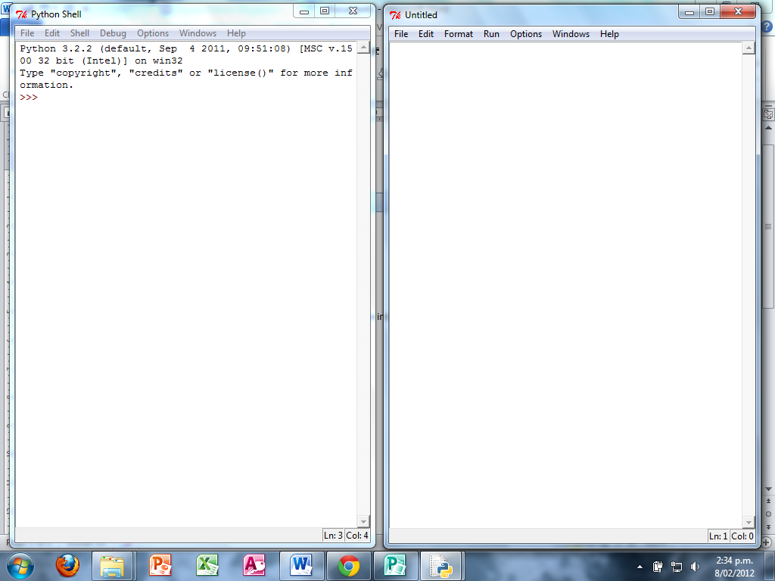

This is your coding screen. F5 saves and runs your code in the testing screen.

This is your testing screen.

Before you can test, you must save. YOU MUST PUT A .py AT THE END OF YOUR FILE NAME

Ie test.py